Email Spam Detection using Multinomial Naive Bayes
1. Overview
This project implements a Supervised Machine Learning model to classify email messages as either "Spam" or "Ham" (legitimate). By leveraging the Multinomial Naive Bayes algorithm.
2. Technical Background
What is Naïve Bayes and Multinomial Naïve Bayes?
- Naive Bayes is a popular supervised machine learning algorithm primarily used for classification tasks. It is built upon the mathematical principles of Bayes' Theorem. Here in this project Bayes' Theorem calculates the probability of a message being "Spam" given the words it contains. It is called "naive" because it makes the simplifying assumption that every feature (word) is completely independent of every other feature. In text classification, it ignores the order of words and assumes the presence of one word does not influence the likelihood of another appearing.

- The Multinomial Naive Bayes algorithm is a probabilistic classifier based on Bayes' Theorem. It is specifically designed for text classification because it treats each word in a document as an independent feature.

3. Dataset Preparation & Model Architecture:
- Dataset Composition
The project utilizes the spam.csv dataset, which consists of real-world SMS messages categorized into two classes:
v1 (Target): The label indicating whether the message is 'ham' (legitimate) or 'spam'.
v2 (Feature): The raw text content of the SMS message.
- Data Implementation Steps
To prepare the textual data for the Multinomial Naive Bayes algorithm, the following implementation workflow was followed:
- Preprocessing & Labeling:
    - The raw dataset was cleaned to remove irrelevant columns.
    - The text labels were converted into a numerical format: Ham was mapped to 0 and Spam was mapped to 1.

- Feature Extraction (Vectorization):
    - Since machine learning models cannot process raw text, the CountVectorizer utility was used to convert the messages into a Matrix of Token Counts.
This process counts the frequency of every unique word across the dataset to create a numerical feature set.

- Data Partitioning:
The dataset was split into a training set (80%) and a testing set (20%) using a fixed random_state=42 .

- Model Selection:
    - The Multinomial Naive Bayes classifier was chosen due to its high efficiency in handling discrete features like word counts in text documents.
    - The model was trained using the fit() method on the vectorized training data.

4. Performance Analysis:
The model demonstrates high precision in filtering spam while minimizing the “False Positive" rate.
- Advanced Performance Metrics
The classification report highlights the model's ability to balance Precision (the accuracy of spam predictions) and Recall (the ability to find all spam messages).

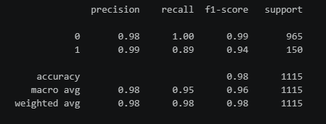
5. Project Conclusion:
The Multinomial Naive Bayes implementation proved to be an efficient and computationally lightweight solution for text classification. The model successfully established a clear boundary between spam and ham, making it a reliable tool for automated email filtering.

